HEADLINE - “House of the Day: Winter Park home near Lake Maitland asking $1,690,000.”

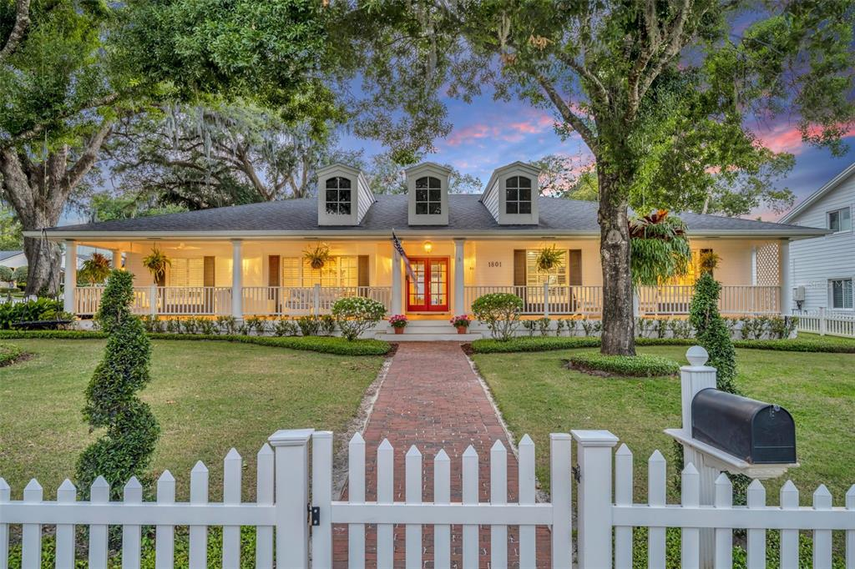

This four-bedroom, three-and-a-half-bathroom home is located at **1801 Legion Drive** [[**GMap**](https://www.google.com/maps/place/1801+Legion+Dr,+Winter+Park,+FL+32789/@28.6159383,-81.3590786,16z/data=!3m1!4b1!4m6!3m5!1s0x88e77039aa58c0a5:0x4341a81a33f56005!8m2!3d28.6159383!4d-81.3590786!16s%2Fg%2F11c2cth5p9?entry=ttu)] in Winter Park, just seconds away from Lake Maitland, and easy access to top-rated schools, shopping on Park Avenue, and top-notch recreational amenities like Enzian Theater.

The Southern traditional home sits on a 100x150-foot corner lot with a large front porch, tucked behind a white picket fence. The home has an additional bedroom and full bath in the detached guest quarters.

The large gourmet kitchen features white cabinetry, a stainless steel Thermador gas range, and a GE Monogram built-in refrigerator and microwave. The adjacent family room opens to the kitchen and has custom-built shelving around a brick fireplace, which is an ideal place to gather for family movie nights.

The main bedroom has French doors and two custom-built shelved closets, one of which is a large walk-in. The central laundry room is conveniently located between the split bedroom plan, the secondary master has its own en-suite bathroom, and two more bedrooms share a bath.

French doors lead to a large covered porch with detached guest quarters, which would also be a great place for a future home gym. The pool is saltwater and was installed in 2018. There is also a hot tub and the roof was redone in 2019.

The asking price is $1,690,000.

**Click** [**HERE**](https://www.realtor.com/realestateandhomes-detail/1801-Legion-Dr_Winter-Park_FL_32789_M63982-96706?cid=txt_shares_core_ldp_android&source_caller=sdk&pid=af_app_invites&af_sub4=LDP&shortlink=iqrow8qs&af_sub2=https://www.realtor.com/realestateandhomes-detail/1801-Legion-Dr_Winter-Park_FL_32789_M63982-96706?cid=txt_shares_core_ldp_android&af_referrer_customer_id=50839304-1172-45d7-8619-f06e5fee5a84&deep_link_value=https%3A%2F%2Fwww.realtor.com%2Frealestateandhomes-detail%2F1801-Legion-Dr_Winter-Park_FL_32789_M63982-96706%3Fcid%3Dtxt_shares_core_ldp_android&af_channel=txt_shares_core_ldp_android&af_siteid=com.move.realtor&af_sub3=txt_shares_core_ldp_android&af_referrer_uid=1657486698305-6984824617919344371) for the listing or contact Lori and Bryan Trippler at btrippler@gmail.com.

[INSERT REMAINING PHOTOS]